Created database
Created tables
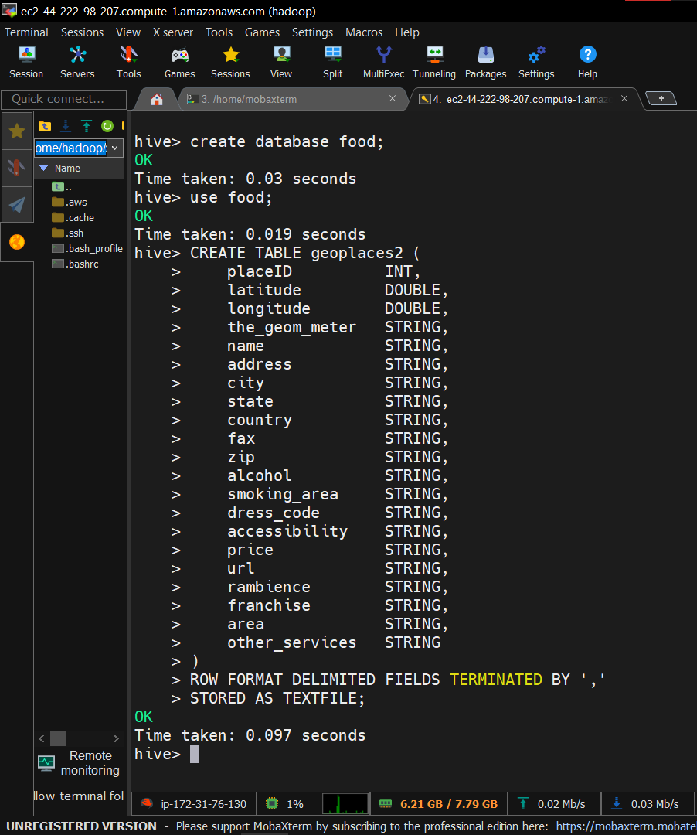

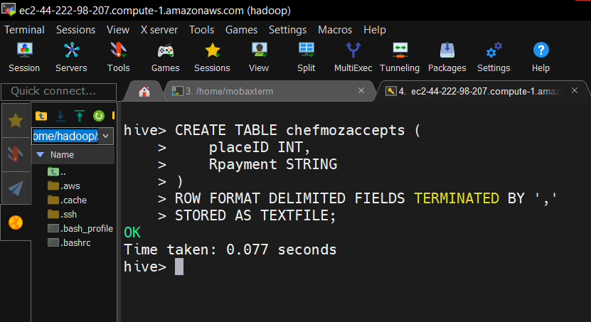

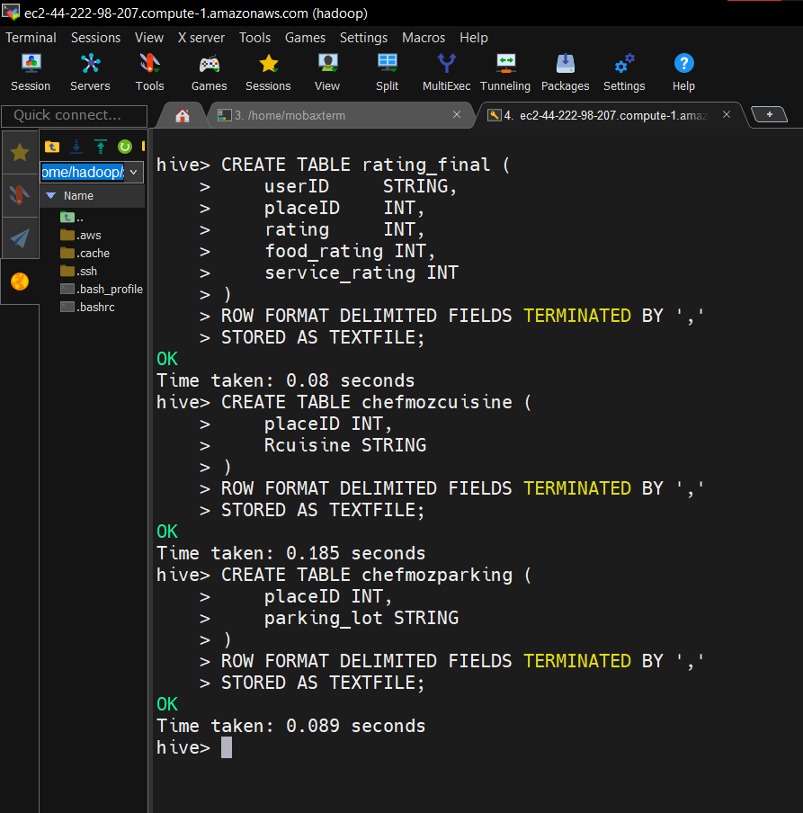
Loaded data into tables;
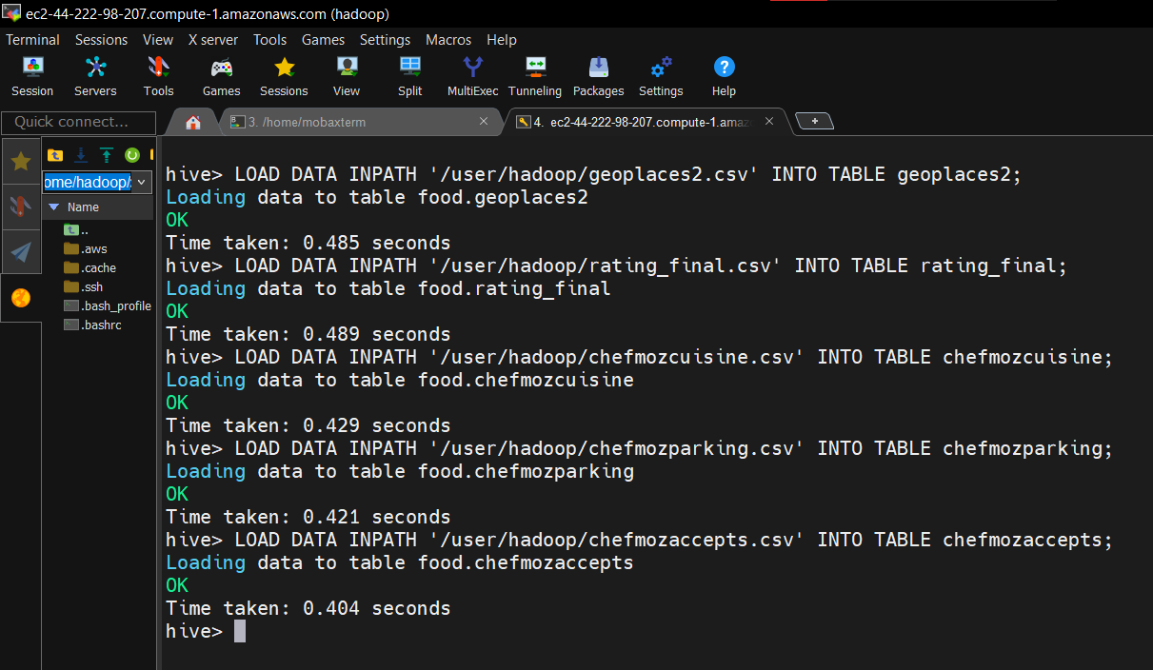

- Total visits to all restaurants under all alcohol categories
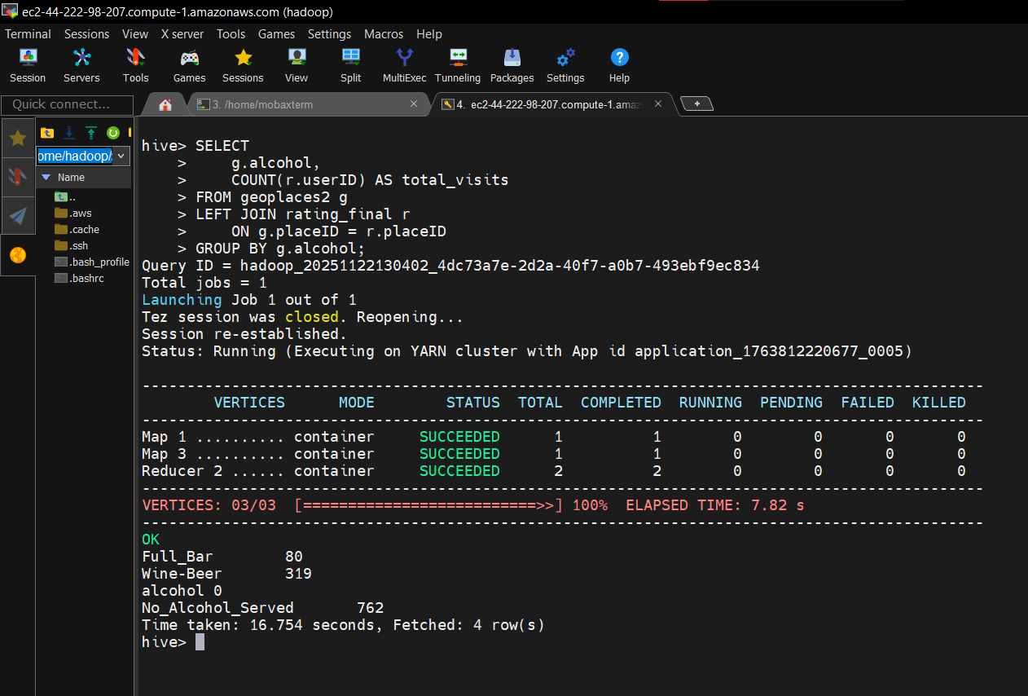

- Average rating by alcohol and price
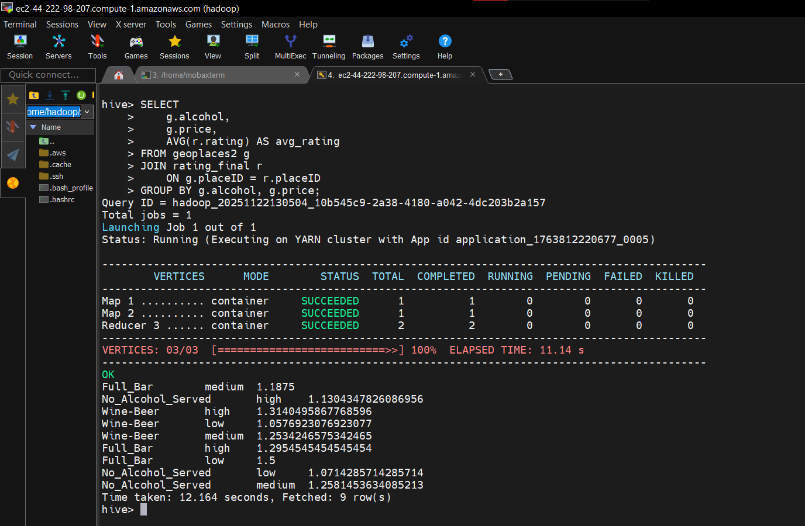
- Parking availability by alcohol category + number of restaurants
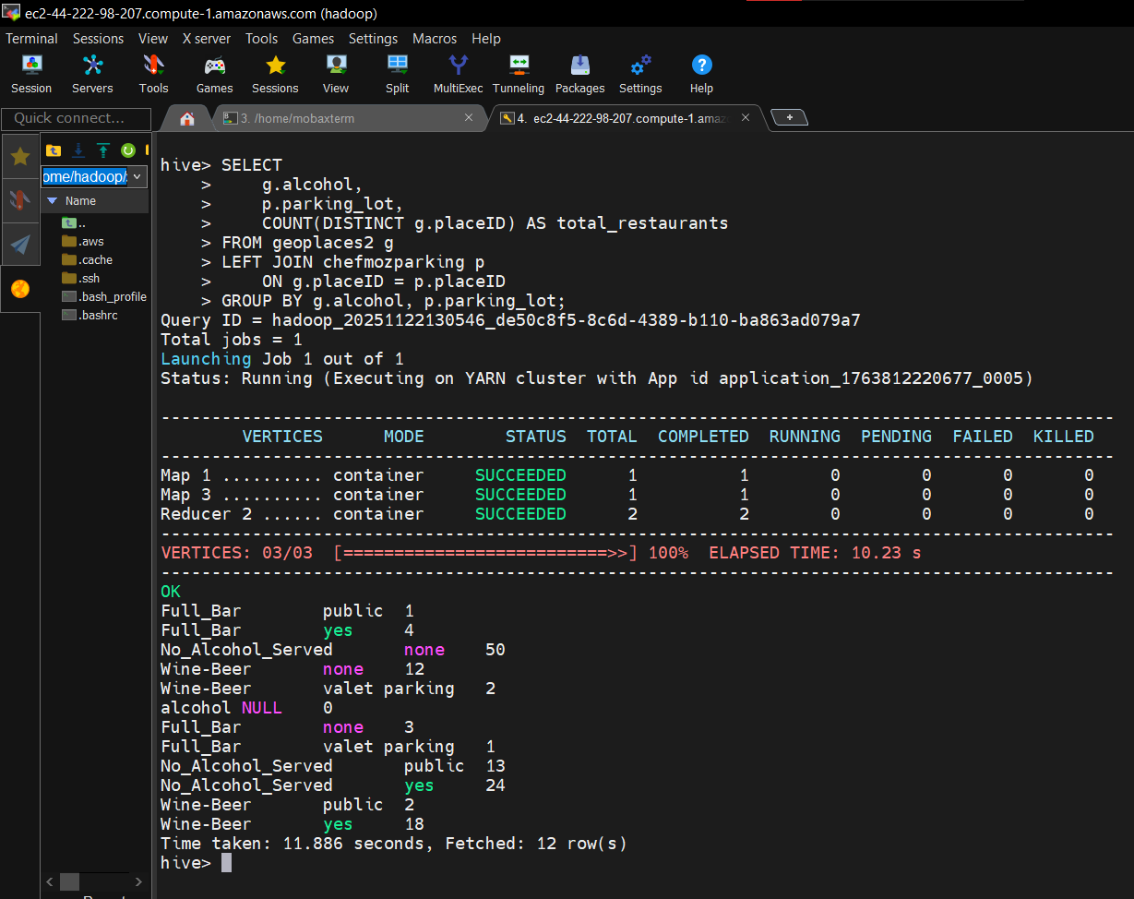

- Percentage of cuisines in each alcohol type

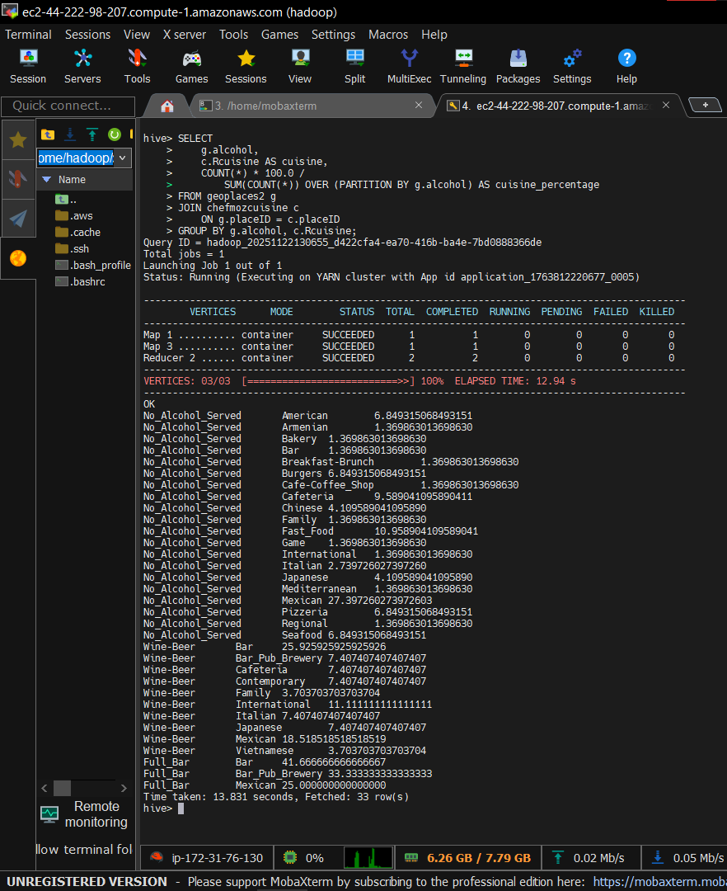

- Average rating of each state
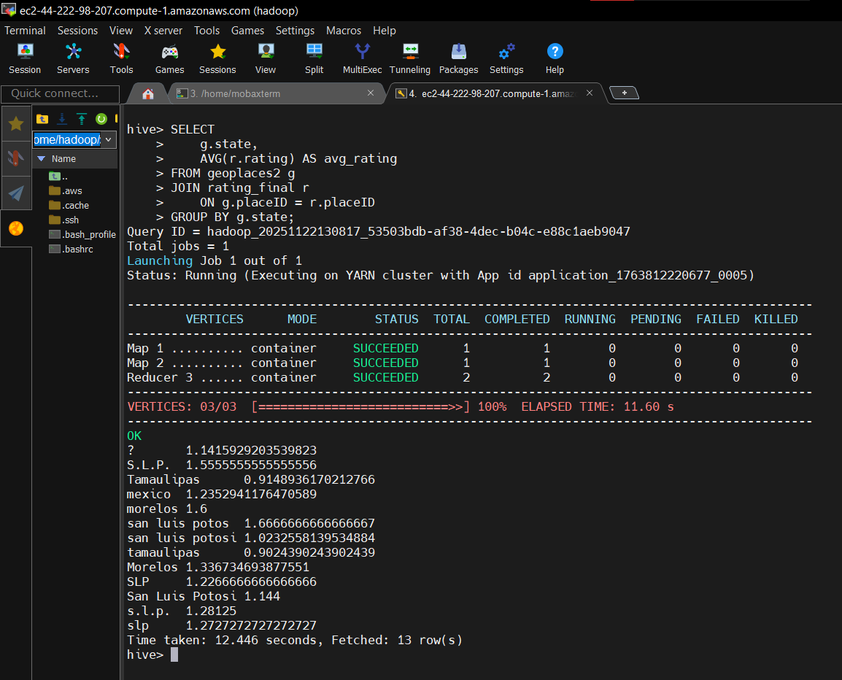

- Why 'Tamaulipas' is lowest-rated – Summary by State, Alcohol, Cuisine
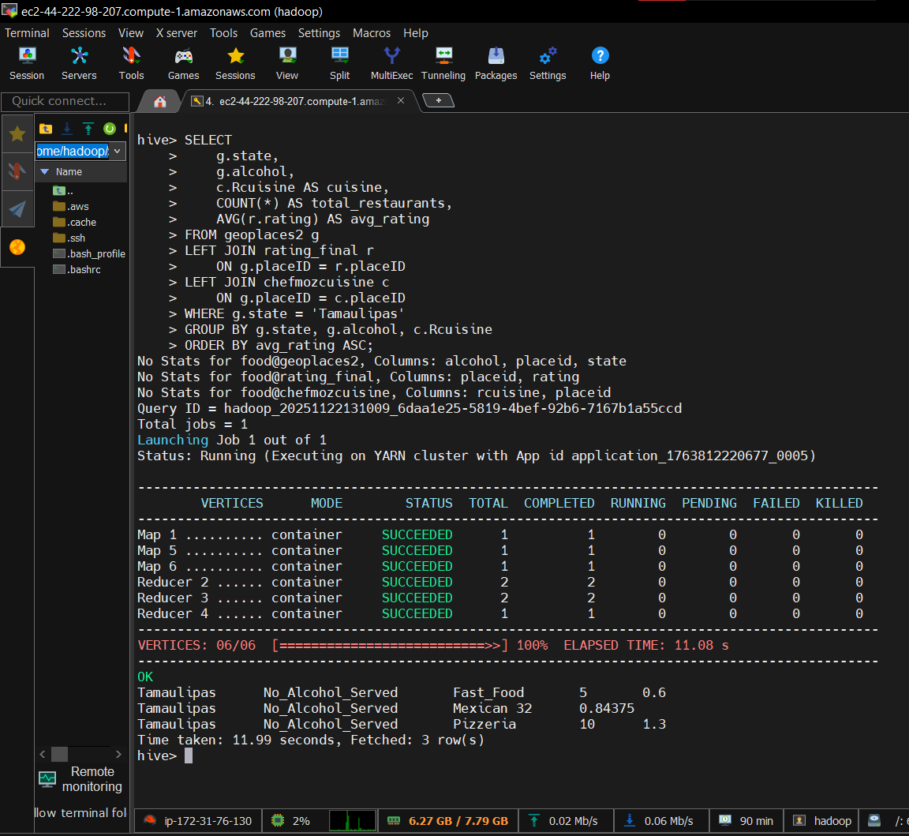

- Why 'Tamaulipas' is lowest-rated – Summary by State, Alcohol, Parking
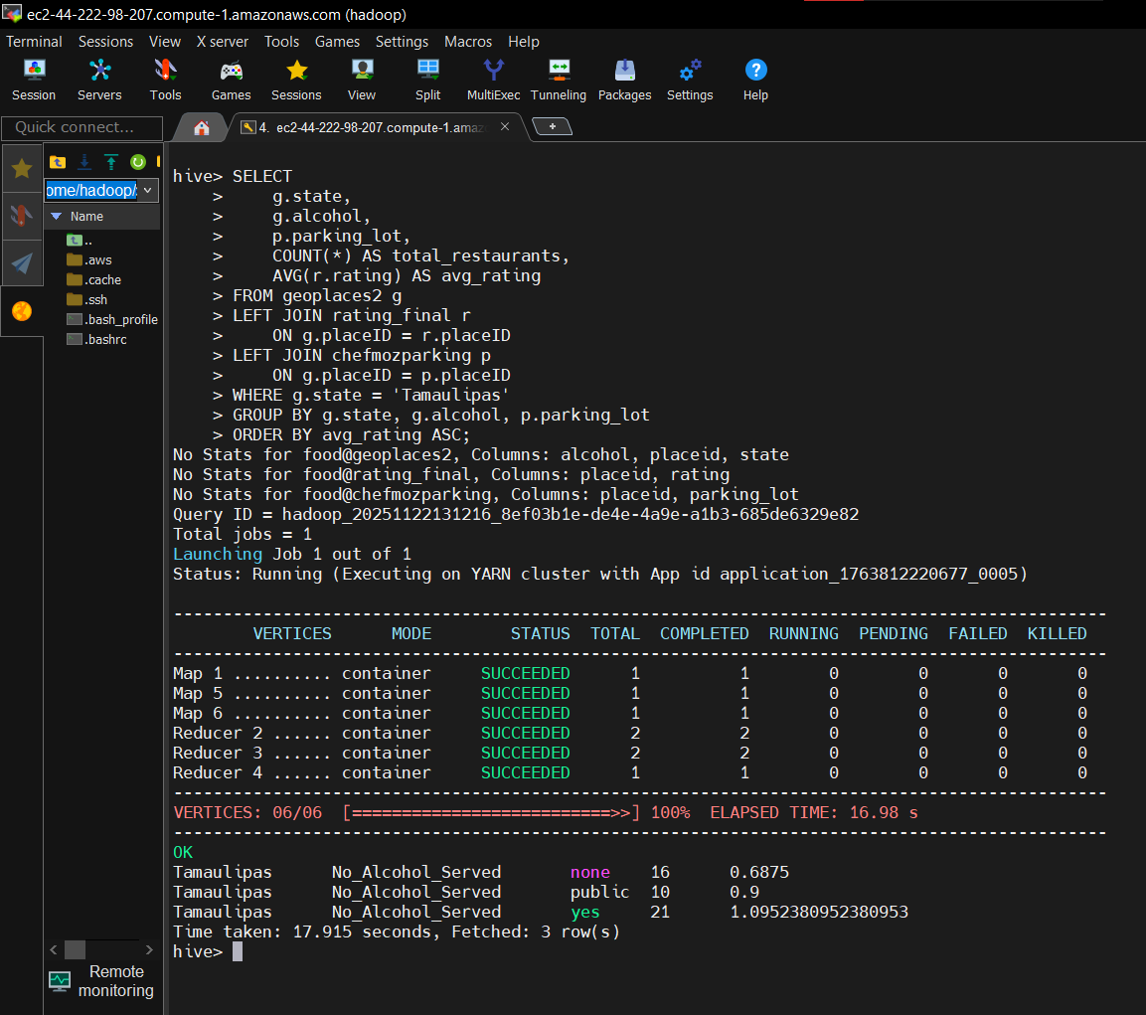

- Restaurants having 'valet parking'

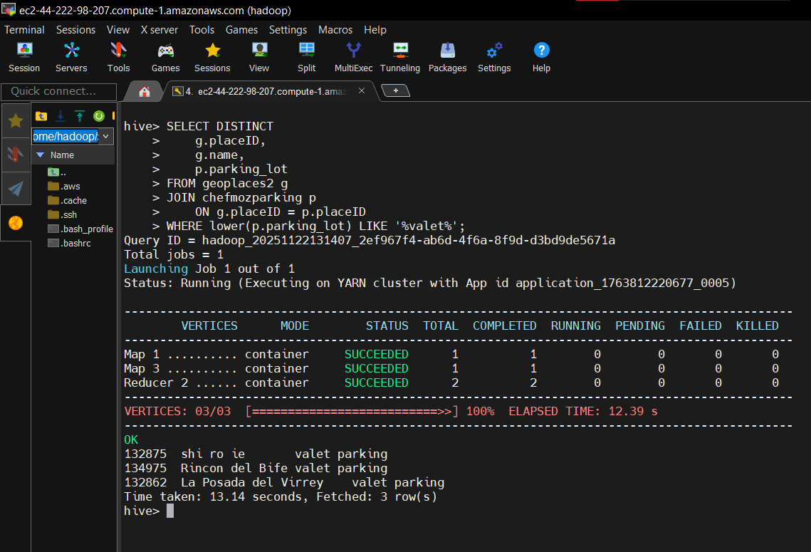
- Restaurants serving 'Fast Food' cuisine
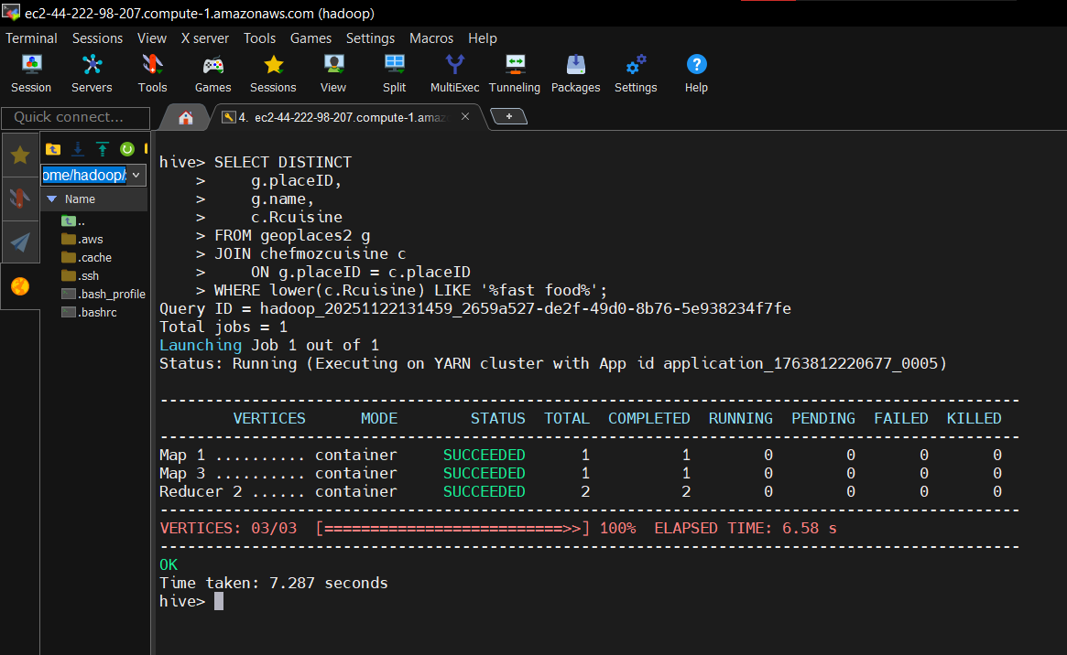
- Cuisines for which users paid using bank debit cards
